b
Batch: B2 Roll No.: 16010121200

Experiment / assignment / tutorial No. 1

TITLE: Requirement Specification Document

AIM: To learn and understand the way of analysing the gathered information in the previous phase for the development process and prepare requirement specification document. A concept of software engineering. ______________________________________________________________________
Expected Course outcome of Experiment:

Process of gathering requirements and converting them into specifications.
Document created will be used by both, the customer and the developer, to understand WHAT is going to be developed.
_____________________________________________________________________
Books/ Journals/ Websites referred:

1. Roger Pressman, Software Engineering: A practitioners Approach, McGraw Hill, 2010 ,6th edition
2. Ian Somerville, Software Engineering , Addison Wesley,2011,9th edition
- http://en.wikipedia.org/wiki/Software_requirements_specification
_____________________________________________________________________
Pre Lab/ Prior Concepts:

Requirements analysis in systems engineering and software engineering, encompasses those tasks that go into determining the needs or conditions to meet for a new or altered product, taking account of the possibly conflicting requirements of the various stakeholders, such as beneficiaries or users. It is an early stage in the more general activity of requirements engineering which encompasses all activities concerned with eliciting, analyzing, documenting, validating and managing software or system requirements.
Requirements analysis is critical to the success of a systems or software project. The requirements should be documented, actionable, measurable, testable, traceable, related to identified business needs or opportunities, and defined to a level of detail sufficient for system design.
Conceptually, requirements analysis includes three types of activities:
- Eliciting requirements: the task of identifying the various types of requirements from various sources including project documentation, (e.g. the project charter or definition), business process documentation, and stakeholder interviews. This is sometimes also called requirements gathering.
- Analysing requirements: determining whether the stated requirements are clear, complete, consistent and unambiguous, and resolving any apparent conflicts.
- Recording requirements: Requirements may be documented in various forms, usually including a summary list and may include natural-language documents, use cases or process specifications.
New systems change the environment and relationships between people, so it is important to identify all the stakeholders, taken into account all their needs and ensure they understand the implications of the new systems. Analysts can employ several techniques to elicit the requirements from the customer. These may include the development of scenarios, the identification of use cases, the use of workplace observation or ethnography, holding interviews, or focus groups (more aptly named in this context as requirements workshops, or requirements review sessions) and creating requirements lists. Prototyping may be used to develop an example system that can be demonstrated to stakeholders. Where necessary, the analyst will employ a combination of these methods to establish the exact requirements of the stakeholders, so that a system that meets the business needs is produced
Different types of Requirements
- Functional requirements
- Usability requirements
- Reliability requirements
- Performance requirements
- Security requirements
A typical SRS document template is shared subsequently. This document acts as a reference and will be used by both, the customer (for whom the software system is to be developed), and the organization which develops the solution. Typically, prepared by the development organization at the early stage of development by the professionals after interacting with the customer.
Software Requirements Specification for:
<Project>
Version 1.0
Prepared by Anurag Shahal, Sarfaraz Shaikh, Asmi Takle
<Organization>
<Date created>

Table of Contents
Table of Contents ii
1. Introduction 1
1.1 Purpose 1
1.2 Product Scope 1
1.3 References 1
2. Overall Description 2
2.1 Product Perspective 2
2.2 Product Functions 2
2.3 User Classes and Characteristics 2
2.4 Operating Environment 2
2.5 Design and Implementation Constraints 2
2.6 User Documentation 2
2.7 Assumptions and Dependencies 3
3. External Interface Requirements 3
3.1 User Interfaces 3
3.2 Hardware Interfaces 3
3.3 Software Interfaces 3
3.4 Communications Interfaces 3
4. System Features 4
4.1 System Feature 1 4
4.2 System Feature 2 4
5. Other Nonfunctional Requirements 4
5.1 Performance Requirements 4
5.2 Safety Requirements 5
5.3 Security Requirements 5
5.4 Software Quality Attributes 5
5.5 Business Rules 5
6. Other Requirements 5
Appendix A: Glossary 5
Appendix B: Analysis Models 5
Appendix C: To Be Determined List 6

Introduction

Purpose
The pandemic situation has encouraged many people to start their own small business, but due to lack of connectivity and customer reach, upscaling becomes a difficult task for small business owners. There is a need for an exclusive platform for consumers to connect with blooming small scale businesses and for the business owners to showcase their products and to create contacts.
Problems are faced by businesses new in the market to showcase their product to gain customer reach. There is a need for a platform to connect small scale business owners to the local consumers. The businesses can register themselves and can post details about their products which the consumers can look up to and can subsequently connect with the business owners.
Thus, create a web application that connects small scale businesses with larger audiences and blooms local businesses.

Product Scope
• To design a website with user friendly, easy to understand interfaces.
• To provide a login and registration facility for the user.
• To provide registered users with the facility to post details about their products.
• To design appropriate server backends for storing and retrieving details.
• The consumers can look up businesses on the website as per their requirements.
• The consumers can connect with the business of their choice.
• The consumers can post feedback of their experience with a product.

References
Ours is a budding project and at its beginning stages it has taken inspiration from many great tech companies and their approach towards building their user interface clean and subtle. In order to make the frontend look attractive, seamless and simple at the same time we had to refer to the styling and design of various websites. Some of the websites used to references are:
❏ Amazon.com
❏ Amazon Prime Video
❏ Netflix India
Graphic illustrative images for backgrounds were designed using tools like
❏ Canva: Create Amazing Graphic Design Our approach for the backend of this website project was fairly conventional and followed the official documentation of Django for most of the part. The database chosen was SQLite3 as it is the most compatible database system with Django projects. However, whenever we found ourselves stuck at a backend problem, we referred to the following websites.
❏ Tech with Tim
❏ Ecommerce Website - Course
❏ Django documentation

Overall Description

Product Perspective

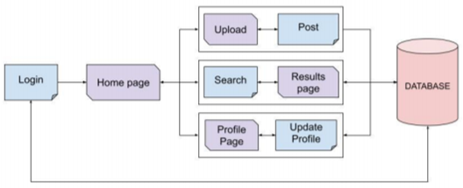

Product Functions
Models | Description
Customer | All registered businesses are stored in the Customer Model.  Uses id as the primary key.
Post | Posts from all users are stored in the Post Model.  Uses p_id as the primary key and refers to the Customer model using Customer id as the foriegn key.
Comment | Comments received on all posts are stored in the Comment Model. Uses c_id as the primary key and refers to the Post model using Post p_id as the foriegn key.

Function/Module | Description
Login-Registration | Handles registration of new users and validates the credentials of registered users trying to log in.
HomePage | Renders the landing page of the website that contains data about various products and businesses registered with the website. It also provides a way to access other functionalities such as Search , Filters and Upload a Post.
Search | A feature that can be used to search a particular product based on the product name or a phrase matching the product description. The search results are rendered in a new webpage.
Profile | Renders the profile page of the registered user. It contains information about the business and the products that the business offers.
Upload | A posting feature where registered users can upload an image of their product along with its description and certain general details required
Post View | Renders the page that provides detailed information about any particular product that has been posted on the website along with the comments related to the post.
Profile View | Render the page that provides detailed information about a particular business along with all of its products that have been registered with the website.
Delete Post | A confirmation page where the user is redirected to in case any of the uploaded posts needs to be permanently deleted.

Operating Environment

Hardware Requirements:
● Minimum 4GB RAM Windows machine.
● 25 MB free storage for programming implementation (excluding storage required for IDE,Browser and uploaded media files )

Software Requirements:
● Windows 7 or above.
● Any windows supported browser like FireFox, Brave etc.
● Google Chrome version 18 or above.(Preferable)
● Python v3.7 or above.

Design and Implementation Constraints
● Currently this software is available in only one language.
● The security features currently provided are very basic.
● Machine learning algorithms are currently not applied.

User Documentation
No user manual or online help tutorials are delivered along with the software. The software aims to be self-explanatory to the users.

Assumptions and Dependencies

Assumptions:
● Users are expected to have a stable internet connection.
● The access to the database is fast.
● All the information like contact details,name,etc provided by the users is correct.

Dependencies:
● Hardware features of the server. Any problem in the server will result in the malfunctioning of the website.
● Ability of the website host to handle particular traffic on the website.

External Interface Requirements

User Interfaces
<Describe the logical characteristics of each interface between the software product and the users. This may include sample screen images, any GUI standards or product family style guides that are to be followed, screen layout constraints, standard buttons and functions (e.g., help) that will appear on every screen, keyboard shortcuts, error message display standards, and so on. Define the software components for which a user interface is needed. Details of the user interface design should be documented in a separate user interface specification.>
User Interfaces include:

Home Page:
Home page contains the following:
1)Navigation Bar:
Contains the several product categories offered to the consumers with easy to navigate on click buttons
2)Login/Sig in button:
Allows previous customers or newly joined users to enter into their account and enjoy
all the services provided by the site
3)Company logo:
For consumers to verify the authenticity of our website
4)Contact us section with details at the bottom of the page:
For customers to report their particular grievances

Login/Sign in page:
1)Will consist of a form with regards to the user details to be filled
2)The form will be different for the login in users and the sig in users
3)Basic and essential details like the user address, number, email id, name and password would be asked to fill.
4)Once signed in the user needs to only fill in the username and password to log back into the same account
s

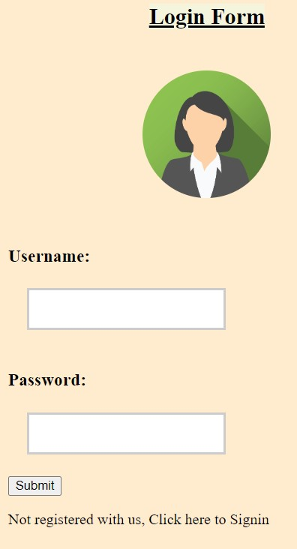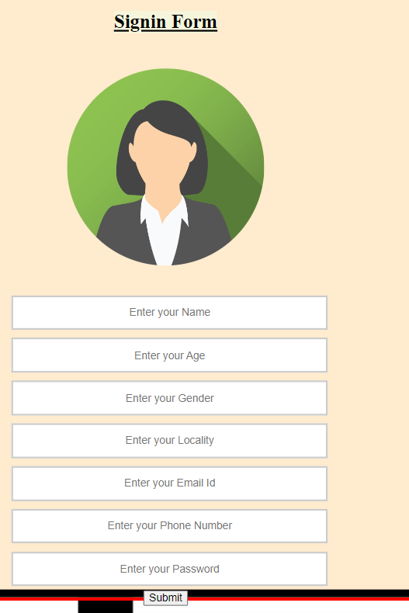

Products Page:

1)Products page will contain all the necessary details and list out all the possible products available at to the customers to purchase.

2)The page will have several products belonging to different categories and will have an option for the customers to select what they prefer and add to the cart or immediately buy

3)Products page will contain product details and also the several sizes available and the different color variants of the same product

4)The products searched by users will also be displayed on the product page once the search is successful. Products will be listed on the page in accordance to the relevance of the product with the searched product

Profile Page:

1)Profile page will consist of the user profile details along with their previous order details

2)All the details confidential to the user will appear on this page and can only be accessed on successful login into the account by the particular user

Product Cart Page:

1)Will consist of all the products that were entered into the cart by the user

2)An option to checkout will be given to the user with all the products added in its cart

3)Also a delete option will be provided to remove unwanted products before checking out

4)A clear cart option will also be provided in case the user changes its mind

Checkout Page:

1)Checkout Page will consist of the items that have been selected by the user to buy

2)Various payment methods and options will be provided to the user for the transaction to be completed successfully

3)Once the payment details have been approved and the transaction has been completed the user will receive a notification indicating the transaction is complete

4)An invoice will be mailed to the user

5)User will then be directed to the home page once again

Hardware Interfaces
Since it is a website, all users will need is basic hardware like PC, keyboard,mouse,etc along with a stable internet connection.

Software Interfaces

Programming Languages and Frameworks:
● Python 3.8
● HTML
● CSS
● Javascript
● SQLite3
● Bootstrap 4.2 Framework
● Django Web Development Framework 7

Development Tools:
● Microsoft Visual Studio Code v1.5
● Github

Communications Interfaces
- HTTP protocol will be used for transfer of data.
- Stable internet connection is required for inserting/ fetching data from the database.
- Valid contact details must be provided by the users.

System Features
4.1. Register/Signup a local Business.
4.1.1 Description and Priority
- Users should be able to register their business with the website by providing valid details like business name, contact, location etc.
- High Priority

4.1.2 Stimulus/Response Sequences
- User registers using a valid email id and password.
- Registered users are required to enter business details.

4.1.3 Functional Requirements
- Secure database to store user details
- Authentication to permit valid login only
REQ-1: A database that stores email address and passwords of registered users in a secure and tamper proof manner.
REQ-2: An authentication service that permits only registered users by examining the input credentials with those stored in the database.
REQ-3: In case of invalid credentials display the corresponding error, whether it is an incorrect password or an incorrect email id.
REQ-4: If the credentials are valid, redirect the user to the profile page or the home page.
4.2. Product Display
4.2.1 Description and Priority.
- All logged in users with a complete vendor profile should be able to post information about the products their business offers.
- High Priority.
4.2.2 Stimulus/Response Sequences
- There should be an option to add new products
- On the add products page, user may be able to provide details about the product such as:
  - Product name.
  - Product description.
  - Product price.
  - Product category.
  - Image of the product.
4.2.3 Functional Requirements
- A database that stores information about the post, contact details of the vendor as well other information regarding the product.
REQ-1: Only a registered user with a completed profile will be allowed to post information about the product.
REQ-2: If a user with an incomplete profile wishes to upload, he/she must be redirected to the profile page and prompted to complete the profile first.
REQ-3: Upon successful upload, the post will be visible to the user on the profile page.
4.3 Product Feedback/Reviews from customers:
4.3.1 Description and Priority.
- A guest or a registered user can provide feedback on any product uploaded on the website.
- The feedback given on the post would be visible to the owner of the product and other customers.
- There should be an option to sort the reviews according to best, worst and newest.
- Low Priority.
4.3.2 Stimulus/ Response Sequence
- When a detailed view of the post is opened, the user should be provided with a text box to provide feedback/comment on the post.
- All feedback given on a post should be available to the owner of the product.
4.3.3 Functional Requirements
- A database that stores the feedback associated with a particular post.
REQ-1: The database should store information about the user that has provided the feedback, the text of the feedback and the time at which the feedback was provided.
REQ-2: In case of a guest user, consider the username to be “Anonymous”.
4.4 Search and Filter.
4.4.1 Description and Priority
- Users should be able to search for a particular item or business name using a search box that shall be provided in the navigation bar.
- Users should also be able to filter out search items based on location, category and availability.
- High Priority.
4.4.2 Stimulus/Response Sequence
- A search box should provide the functionality of searching.
- The search results should be displayed on the same page, with each searched item displayed in a clickable card.
- The filters should be displayed as dropdowns and results should be displayed on the same page.
4.4.3 Functional Requirements
- A query service that queries data from the database based on filters provided and search texts.
REQ-1: The database should be fully updated and functional for the query service to work efficiently.
4.5 Delete Posts.
4.5.1 Description and Priority
- Registered businesses can withdraw or delete a product from their profile for any reason they wish.
- Low Priority.
4.5.2 Stimulus/Response Sequence
- When a registered user visits their profile page. All of their products are displayed.
- Upon hovering on a particular product, the option to Delete the post should be displayed.
- If clicked on Delete, the user should be redirected to another page and asked for a second confirmation. If the user agrees, the data regarding the post should be deleted from the database. If the user does not confirm, the post should not be deleted and the user should be redirected back to the profile page.

System Feature 2

Other Nonfunctional Requirements

Performance Requirements
- The website should be available 24x7.
- The database should remain active for reads and writes for the entire duration whenever the website is active.
- There should not be any delays during the execution of database queries while fetching details.
- The system should have a user-friendly interface such that the user won’t require any tutorial or instructions about the website.

Safety Requirements
- Details of users are safe in the database.
- User credentials like loginId & passwords (in hashed form) are stored securely using authentication provided by django.
- Duplication of database for unforeseen circumstances due to data loss.

Security Requirements
- Unregistered users should not be able to directly access pages that require authentication. In such a case, the user should be redirected to the login page.
- There shouldn’t be any kind of database leaks.
- The passwords of the users shouldn’t be accessible to anyone, not even to the developers.

Software Quality Attributes

Availability:
The website is available to all users in any age group.
Registered business should be valid and verifiable.

Maintainability:
The database has to be maintained properly as it is very important for the product.

Portability:
The product is portable, as it can be accessed from anywhere, with the help of the internet.

Usability:
The website is very user friendly and easy to understand.

Robustness:
The website will be bug free and with negligible ambiguities.

Testability:
All features will be properly tested before use.

Business Rules
- No one other than the user has access to his/her password.
- Users are responsible for the posts they create. (Since it contains contact information,product information,description,etc.)
- Database information about the product availability and product warehouse can only be accessed by the admin

Other Requirements
<Define any other requirements not covered elsewhere in the SRS. This might include database requirements, internationalization requirements, legal requirements, reuse objectives for the project, and so on. Add any new sections that are pertinent to the project.>
Appendix A: Glossary
SQLite3: SQLite is a relational database management system contained in a C library. In contrast to many other database management systems, SQLite is not a client–server database engine. Rather, it is embedded into the end program.
IDE: An integrated development environment is a software application that provides comprehensive facilities to computer programmers for software development. An IDE normally consists of at least a source code editor, build automation tools and a debugger.
Appendix B: Analysis Models
Modules
- Login Module
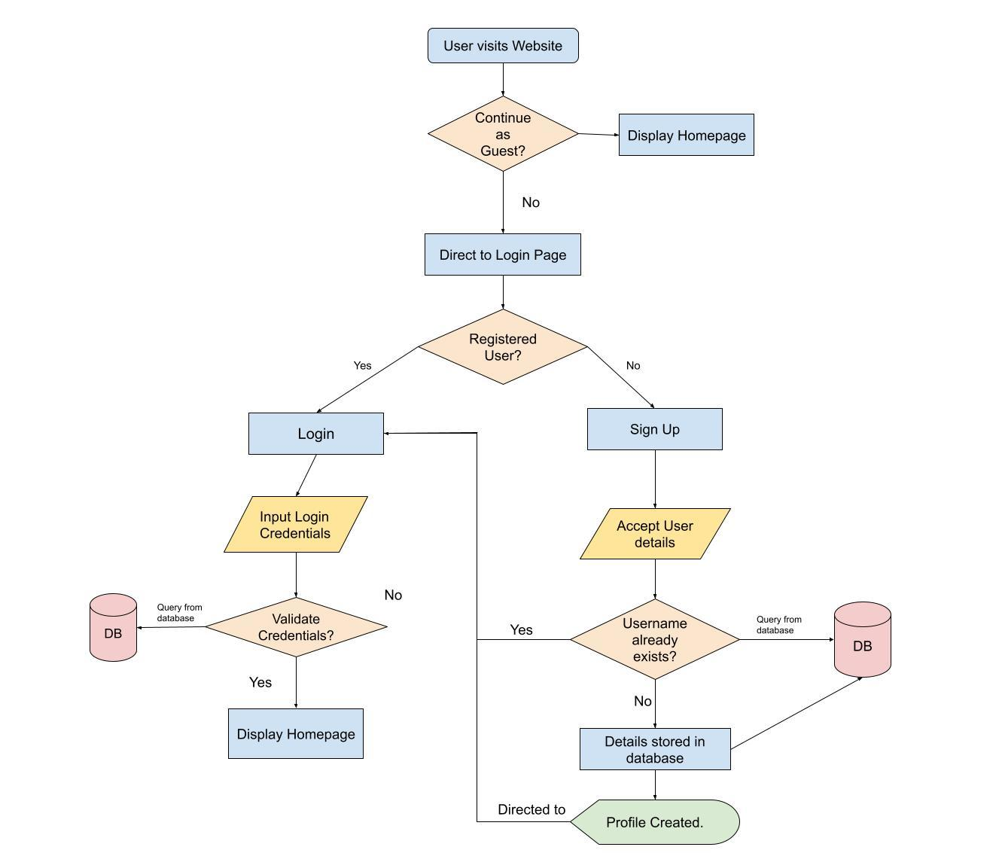

- Post Module
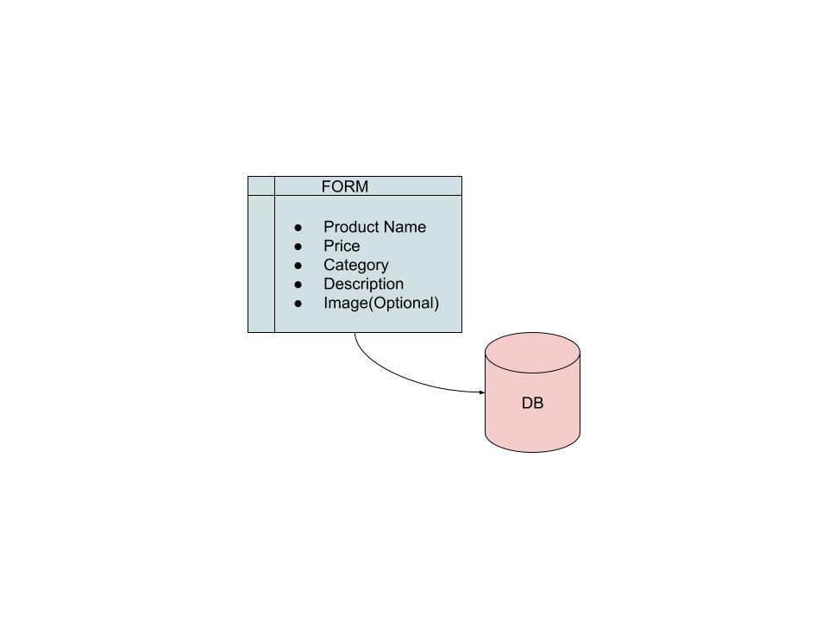

- Search Module

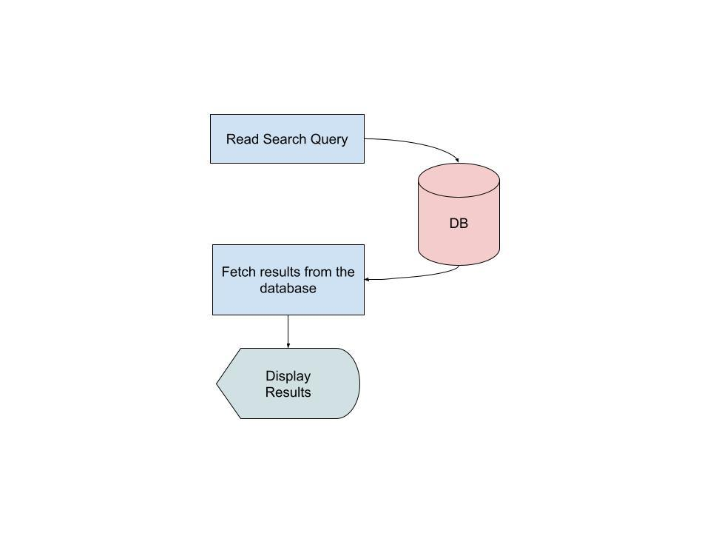

- Update Profile Module

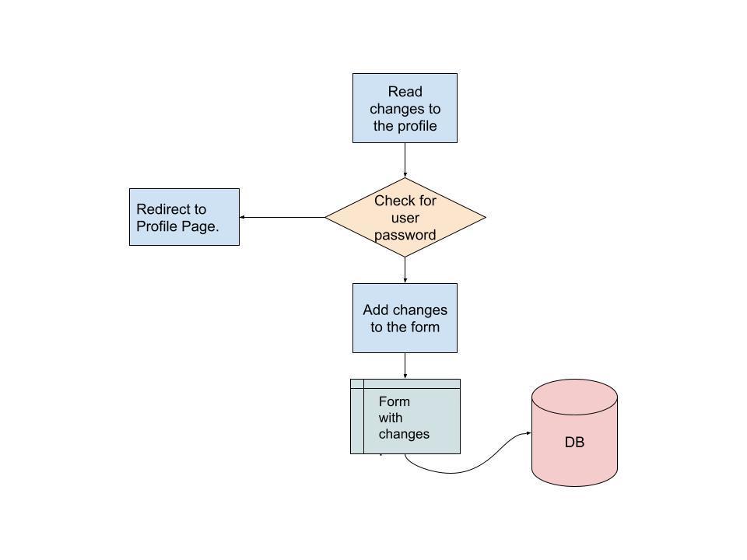

Post Laboratory Activity:

- You are required to prepare SRS document for any project. ( It could be the mini project you have completed in semester IV
- Prepare questionnaire for the allotted project considering your lab instructor is the client for requirement gathering.
- Consider following scenario: An institute is interested in developing a Library Information System (LIS) for the benefit of students and employees of the institute. LIS will enable the members to borrow a book (or return it) with ease while sitting at his desk/chamber. The system also enables a member to extend the date of his borrowing if no other booking for that particular book has been made. For the library staff, this system aids them to easily handle day-to-day book transactions. The librarian, who has administrative privileges and complete control over the system, can enter a new record into the system when a new book has been purchased, or remove a record in case any book is taken off the shelf. Any non-member is free to use this system to browse/search books online. However, issuing or returning books is restricted to valid users (members) of LIS only.

The final deliverable would a web application (using the recent HTML 5), which should run only within the institute LAN. Although this reduces security risk of the software to a large extent, care should be taken no confidential information (e.g. passwords) is stored in plain text.

Prepare SRS document for the same in the format discussed in the write-up.

Post Lab Descriptive Questions
1. What are different techniques to gather information for software development?
Ans :-

The following are some of the well-known requirements gathering techniques −
- Brainstorming: Brainstorming is used in requirement gathering to get as many ideas as possible from a group of people. Generally used to identify possible solutions to problems, and clarify details of opportunities.

- Document Analysis: Reviewing the documentation of an existing system can help when creating AS–IS process documents, as well as driving gap analysis for scoping of migration projects. In an ideal world, we would even be reviewing the requirements that drove creation of the existing system – a starting point for documenting current requirements. Nuggets of information are often buried in existing documents that help us ask questions as part of validating requirement completeness.

- Focus Group: A focus group is a gathering of people who are representative of the users or customers of a product to get feedback. The feedback can be gathered about needs/opportunities/ problems to identify requirements, or can be gathered to validate and refine already elicited requirements. This form of market research is distinct from brainstorming in that it is a managed process with specific participants.

- Interface analysis: Interfaces for a software product can be human or machine. Integration with external systems and devices is just another interface. User centric design approaches are very effective at making sure that we create usable software. Interface analysis – reviewing the touch points with other external systems is important to make sure we don’t overlook requirements that aren’t immediately visible to users.

- Interview: Interviews of stakeholders and users are critical to creating the great software. Without understanding the goals and expectations of the users and stakeholders, we are very unlikely to satisfy them. We also have to recognize the perspective of each interviewee, so that we can properly weigh and address their inputs. Listening is the skill that helps a great analyst to get more value from an interview than an average analyst.

- Observation: By observing users, an analyst can identify a process flow, steps, pain points and opportunities for improvement. Observations can be passive or active (asking questions while observing). Passive observation is better for getting feedback on a prototype (to refine requirements), where active observation is more effective at getting an understanding of an existing business process. Either approach can be used.

- Prototyping: Prototyping is a relatively modern technique for gathering requirements. In this approach, you gather preliminary requirements that you use to build an initial version of the solution - a prototype. You show this to the client, who then gives you additional requirements. You change the application and cycle around with the client again. This repetitive process continues until the product meets the critical mass of business needs or for an agreed number of iterations.

- Requirement Workshops: Workshops can be very effective for gathering requirements. More structured than a brainstorming session, involved parties collaborate to document requirements. One way to capture the collaboration is with creation of domain-model artifacts (like static diagrams, activity diagrams). A workshop will be more effective with two analysts than with one.

- Reverse Engineering: When a migration project does not have access to sufficient documentation of the existing system, reverse engineering will identify what the system does. It will not identify what the system should do, and will not identify when the system does the wrong thing.

- Survey/Questionnaire: When collecting information from many people – too many to interview with budget and time constraints – a survey or questionnaire can be used. The survey can force users to select from choices, rate something (“Agree Strongly, agree…”), or have open ended questions allowing free-form responses. Survey design is hard – questions can bias the respondents.

2. List verification and validation techniques for requirements.
Requirement validation is the process of checking that requirements defined for development, define the system that the customer really wants. To check issues related to requirements, we perform requirements validation. We usually use requirements validation to check error at the initial phase of development as the error may increase excessive rework when detected later in the development process. In the requirements validation process, we perform a different type of test to check the requirements mentioned in the Software Requirements Specification (SRS), these checks include:

- Completeness checks
- Consistency checks
- Validity checks
- Realism checks
- Ambiguity checks
- Verifiability

There are several techniques which are used either individually or in conjunction with other techniques to check to check entire or part of the system:

Test case generation: Requirement mentioned in SRS document should be testable, the conducted tests reveal the error present in the requirement. It is generally believed that if the test is difficult or impossible to design than, this usually means that requirement will be difficult to implement and it should be reconsidered.
Prototyping: In this validation techniques the prototype of the system is presented before the end-user or customer, they experiment with the presented model and check if it meets their need. This type of model is generally used to collect feedback about the requirement of the user.
Requirements Reviews: In this approach, the SRS is carefully reviewed by a group of people including people from both the contractor organisations and the client side, the reviewer systematically analyses the document to check error and ambiguity.
Automated Consistency Analysis: This approach is used for automatic detection of an error, such as nondeterminism, missing cases, a type error, and circular definitions, in requirements specifications.

Validation:
- Identification of unstable components/functionalities
- Validation focused on error-handling: complementary (not concurrent) validation regarding the one performed by the development team
- Compliance with software and system requirements
- Black box testing and White box testing techniques
- Experience based techniques

